**Task 11.Use Tkinter module for UI design**

**Aim**:

To use Tkinter module for UI design

**Problem 11.1. Write a Python GUI program to create a label and change the label font style (font name, bold, size) using tkinter module.**

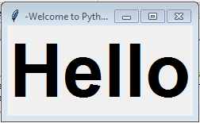

**Algorithm:**

1. Import tkinter module
2. Create a main window
3. Create a label with desired text
4. Add the label to the main window using pack() method
5. Define a function to change font style
6. Create a button to call the function when clicked
7. Add the button to the main window using pack() method
8. Start the main loop.

**Program:**

import tkinter as tk

# Function to change font style

def change_font():

label.config(font=("Arial", 18, "bold"))

# Create main window

root = tk.Tk()

# Create label with desired text

label = tk.Label(root, text="Hello, World!", font=("Helvetica", 14))

# Add label to main window

label.pack()

# Create button to change font style

button = tk.Button(root, text="Change Font", command=change_font)

# Add button to main window

button.pack()

# Start the main loop

root.mainloop()

**Output:**

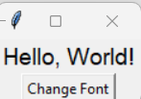

**Task 11.2: Write a Python GUI program to create three single line text-box to accept a value from the user using tkinter module.**

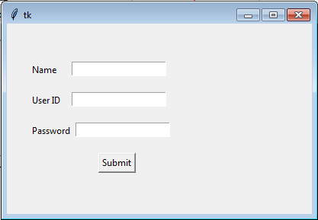

**Algorithm:**

1. Import the tkinter module
2. Create the main window
3. Add labels and text-boxes to the main window
4. Set the size of the text-boxes
5. Create a button to submit the values entered in the text-boxes
6. Get the values entered in the text-boxes when the button is clicked
7. Close the main window when the button is clicked

**Program:**

import tkinter as tk

# Create the main window

root = tk.Tk()

root.title("Text-Box Input")

# Create labels and text-boxes

label1 = tk.Label(root, text="Enter value 1:")

entry1 = tk.Entry(root)

label2 = tk.Label(root, text="Enter value 2:")

entry2 = tk.Entry(root)

label3 = tk.Label(root, text="Enter value 3:")

entry3 = tk.Entry(root)

# Set the size of the text-boxes

entry1.config(width=30)

entry2.config(width=30)

entry3.config(width=30)

# Create a function to get the values entered in the text-boxes

def get_values():

val1 = entry1.get()

val2 = entry2.get()

val3 = entry3.get()

print("Value 1:", val1)

print("Value 2:", val2)

print("Value 3:", val3)

# Create a button to submit the values entered in the text-boxes

submit_button = tk.Button(root, text="Submit", command=get_values)

# Add the labels, text-boxes, and button to the main window

label1.pack()

entry1.pack()

label2.pack()

entry2.pack()

label3.pack()

entry3.pack()

submit_button.pack()

# Run the main event loop

root.mainloop()

Output:

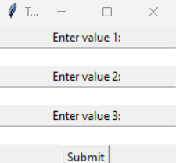

**Result:** Thus the Program using Tkinter module for UI design was executed and verified successfully.